Installing MatLab at Home
Step 1. Instert MatLab Disc 1 into the CD drive, the following should start automatically.

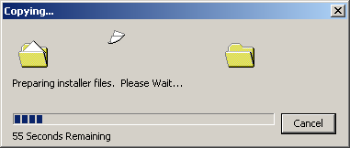

Step 2. Choose Next to Install MatLab

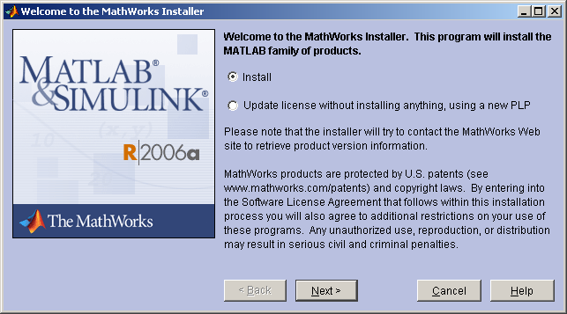

Step 3. Type your name, organization and the Personal License Password (see below)

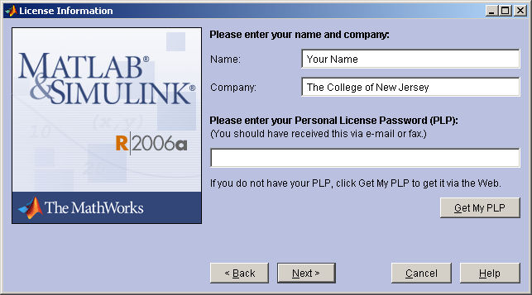

Step 4. The Personal License Password is stored on Disk 1, Navigate to my computer, and right click on your CD drive and click Explore. Open the file “PLP License Number” and highlight the contents, Cut and Paste them into the above field…

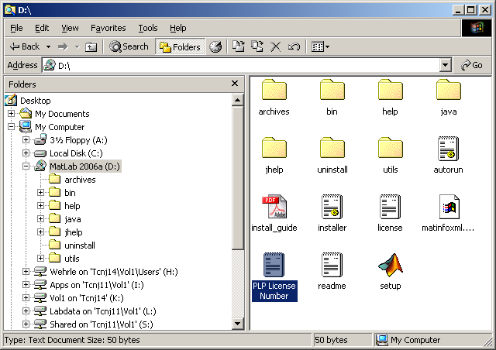
Step 5. Accept the terms of the License Agreement.

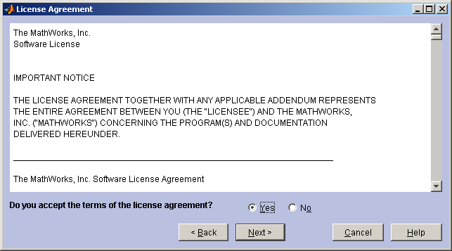

Step 6. Choose your installation type. (Typical is recommended)

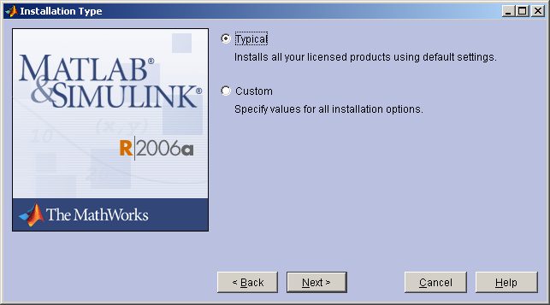
Step 7. Choose the destination folder.

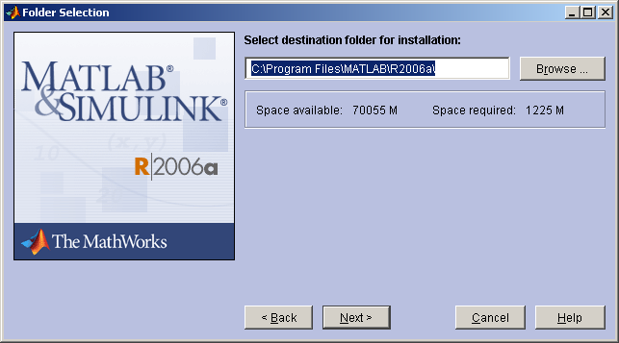

Step 8. If prompted, allow MatLab to create the folder

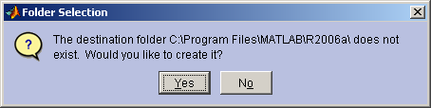

Step 9. Click Install to begin the installation…

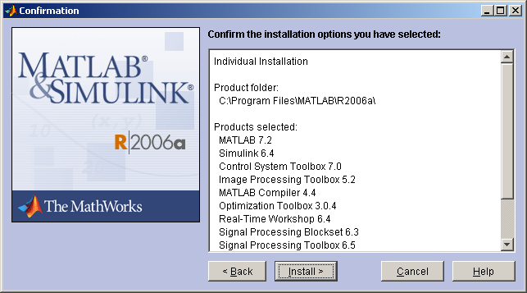
Step 10. Insert CD 2 when prompted and click “ok”
Tip: (Wait a few seconds between putting in CD and clicking OK, so computer can recognize the new CD!!)

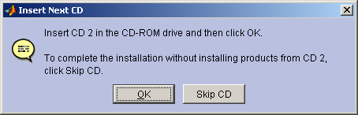

Step 11. Insert CD 3 when prompted and click “ok”
Tip: (Wait a few seconds between putting in CD and clicking OK, so computer can recognize the new CD!!)

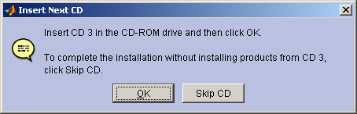

Step 12. Click “Yes to All” to allow MatLab to associate files to itself

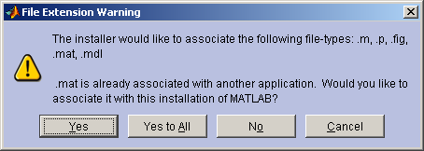
Step 13. MatLab will ask you to check for updates…

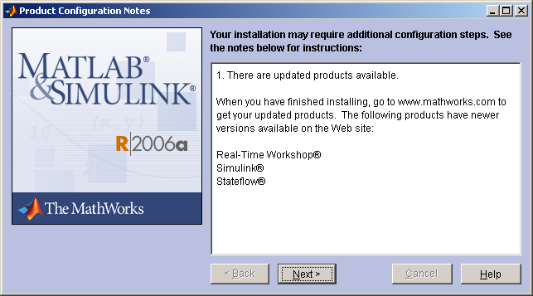

Step 14. MatLab is successfully installed. Please remember to return your disks to ITS in Library Room 004!

